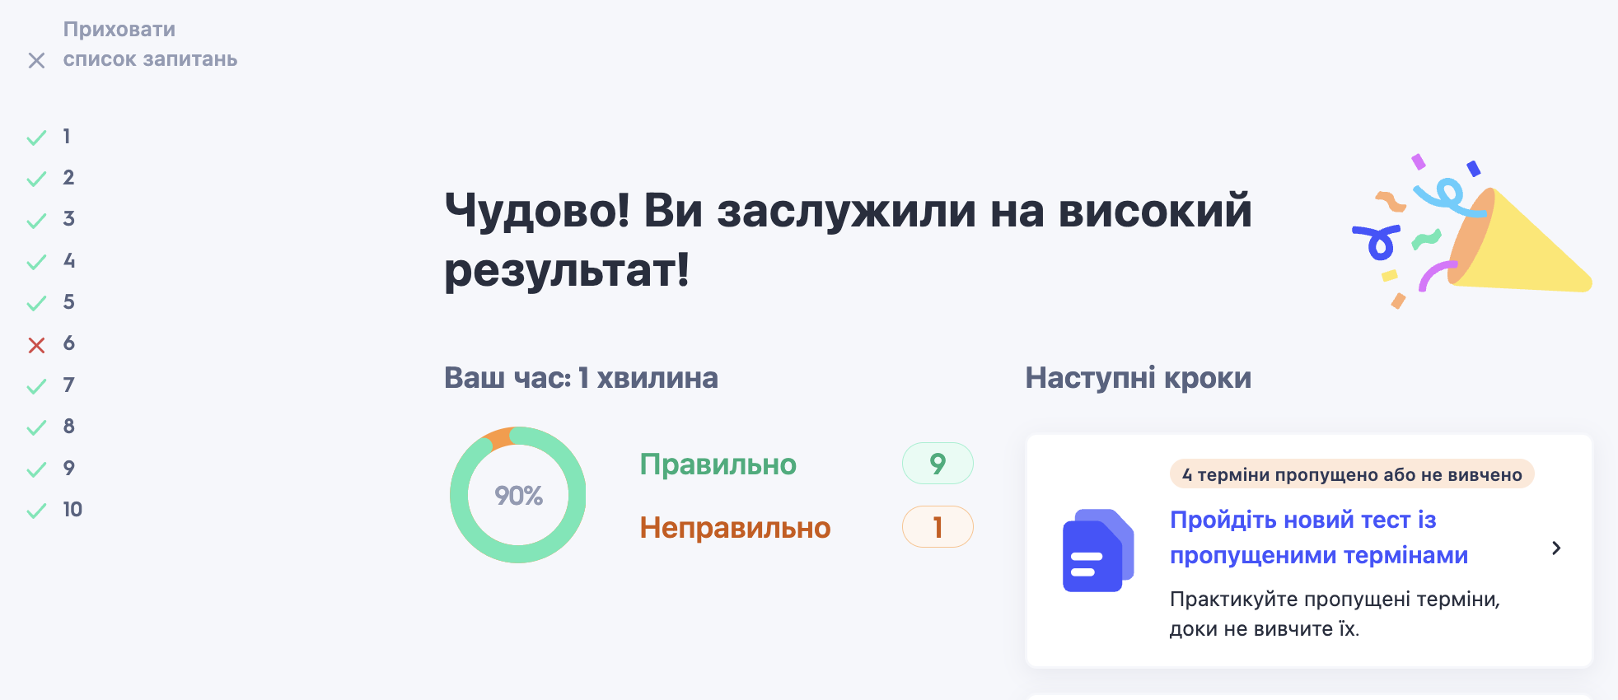

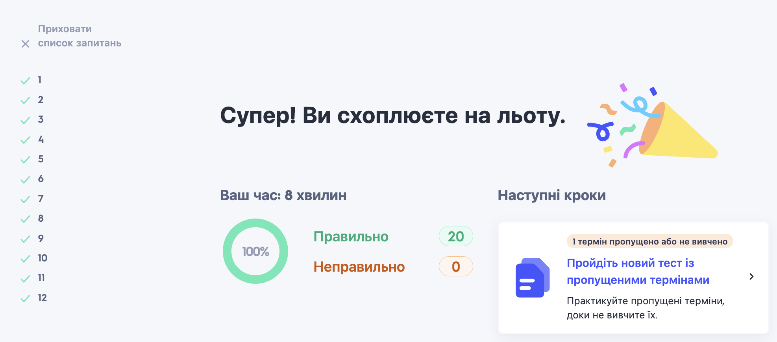

**What are your career goals?**

I am a hardware store manager and my current short-term goal is to develop and use my marketing and communication skills in my work. However, eventually I want to get a more interesting position that will allow me to continue to use these skills.

I recently completed training at GO IT and received a certificate from the Data Analyst course. My long-term goal is to adjust my career from a manager to a data analyst in a large company. I plan to work full-time for the next few years to gain the experience and success I need.